MMM Scotland Residential 2025
Friday 11th-Monday 14th April
Name :

Tel:

emergency contact:

Email:

Address:

Please tick: Meat ( ) Vegetarian ( )

Other (specify)

Please tick:
Residential (3 nights full board accommodation) arrivals from 3pm on Friday 11th April.

£ 340 single room accomodation ( )

Saturday 9.25am-5.50pm (includes morning/afternoon tea & lunch) £80 ( )

Sunday 9.25am-5.50pm (includes morning/afternoon tea & lunch) £80 ( )

Weekend day visitor 9.25am-5.50pm (includes morning/afternoon tea & Lunch) £150 ( )

I have enclosed a cheque for a total of: £

I have paid direct to bank for the total of: £

Please book early to secure a place. £100 non-refundable deposit to be paid by 1st March 2025 and balance by 4th April 2025. Send completed form and cheques £ Sterling UK or International Sterling cheques for deposit to a bank account and made payable to S J Shackleton to: S J Shackleton, Laurieston House, Wallaceton, Auldgirth, Dumfries and Galloway, Scotland, DG2 0TG. Payments can be made directly by Bank Transfer to: Royal Bank of Scotland sort code: 83-33-00, Account No. 15465442. Email: sara.shackleton26@gmail.com (phone-01387 820472)
MMM Scotland, its servants, agents and employees are not under any liability whatsoever in respect of personal injury, loss or damage howsoever caused while attending the course. We therefore advise you to take out personal holiday insurance cover as usual
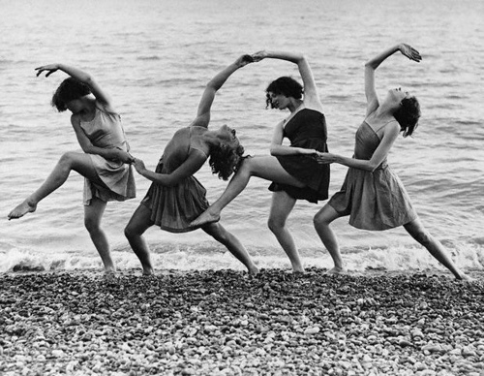
www.margaretmorrismovement.com

