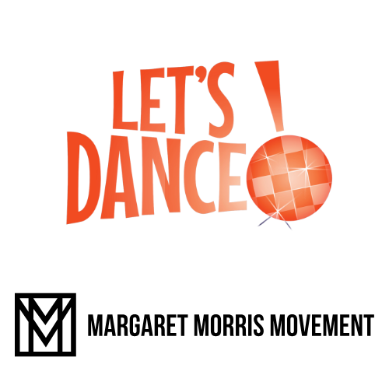



Tips and hints:

- Let’s Dance March 2nd, 2025. This launch date is a Sunday, but the event runs for the whole week. If you cannot do anything on March 2nd, then do not worry, you can do something anytime at any class around that time.
- This is a high-profile event, and the logo on your poster might be enough to attract one or two people to your class.
- This is an editable word document for you to create your Let’s Dance poster.
- To create a poster simply delete this text and add your usual class/contact details.
- Click on the images to move, re-size or delete as you wish.
- Every poster MUST have the Let’s Dance logo and the MMM logo for it to be a recognised Let’s Dance MMM class.
- You do not need to organise a special event; this can replace your usual poster for the week before and after.
- Themes: you do not need a special theme, but the Let’s Dance logo is orange…so that would be a nice and relatively easy to add a bit of MMM orange to your classes.

If you need help, please email Tracy at: directortl@margaretmorrismovement.com

